NavUP System Testing Report

Keoagile Dinake – 15041744

**Due:** 5 May 2017

**Team:** Longsword - Access

**Testing:** Broadsword - Access: Points of Interest

Functional Requirement Report:

| Functional Requirements | Mark (10) | Comment Index |
| --- | --- | --- |
| Search Location | 0 | 1 |
| Save Location | 4 | 2 |
| Get Current Location | 3 | 3 |
| Add Location | 0 | 4 |
| Modify Location | 0 | 5 |
| Remove Location | 0 | 6 |

Comments:

1. This functional requirement couldn’t be tested as there was an error in the searchLocation method. Also, there was no server interaction to persist the searched location. See figure 1.

2. This functional requirement managed to save the location locally, and notify the user, however the saved location was not persisted to the server and saved on the database. As a result, once the page is refreshed all changes are lost. See figure 2.

3. This functional requirement managed to display the “current location”, and I place emphasis on current, mainly because this location is hardcoded and not in any way dynamic. There is no evidence of dynamic calculation of the user’s current location. See figure 2 and 3.

4. This functional requirement could not be tested as the functionality did not work due to an error in the source code relating to the searchLocation method. See figure 4.

5. Same as the case above.

6. Same as the case above.

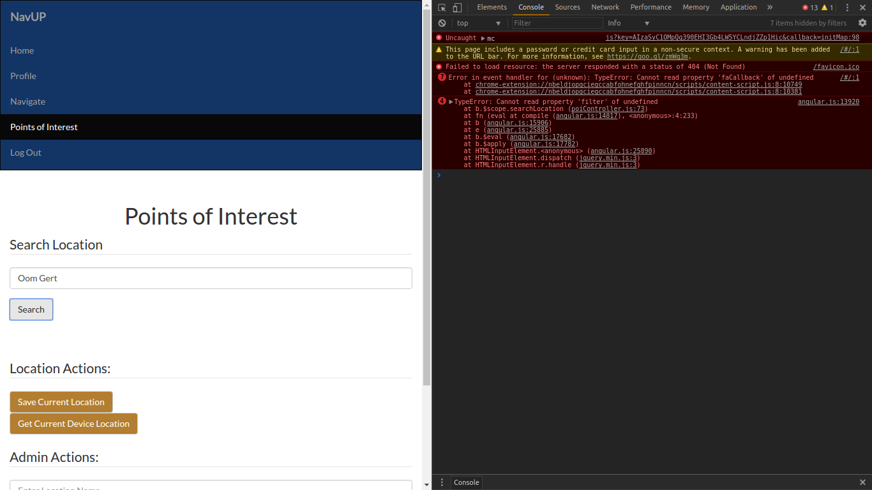Figure 1. Failed use case of searching for a location. See the developer console on the right.

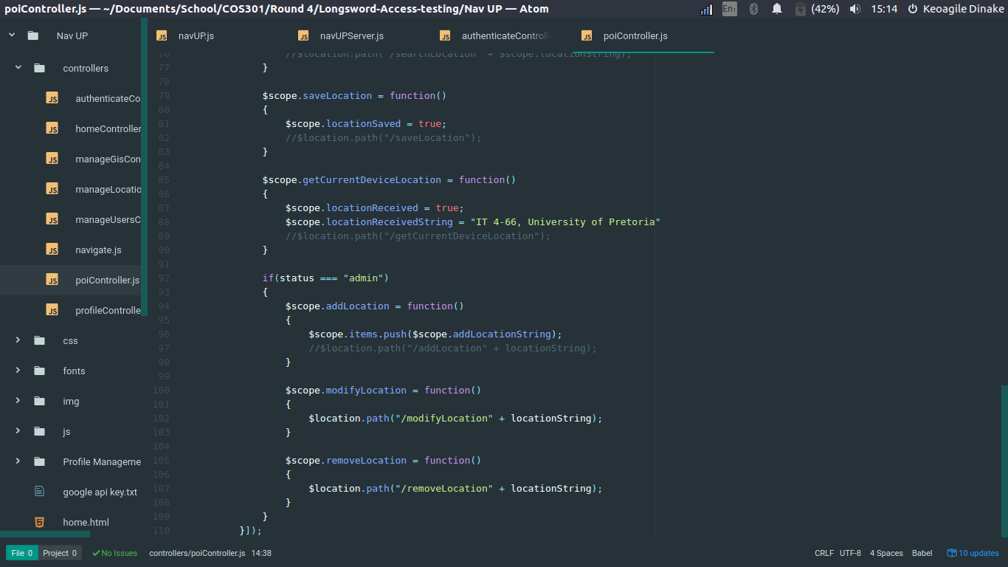Figure 2. Snippet of the saveLocation method and the getCurrentDeviceLocation.

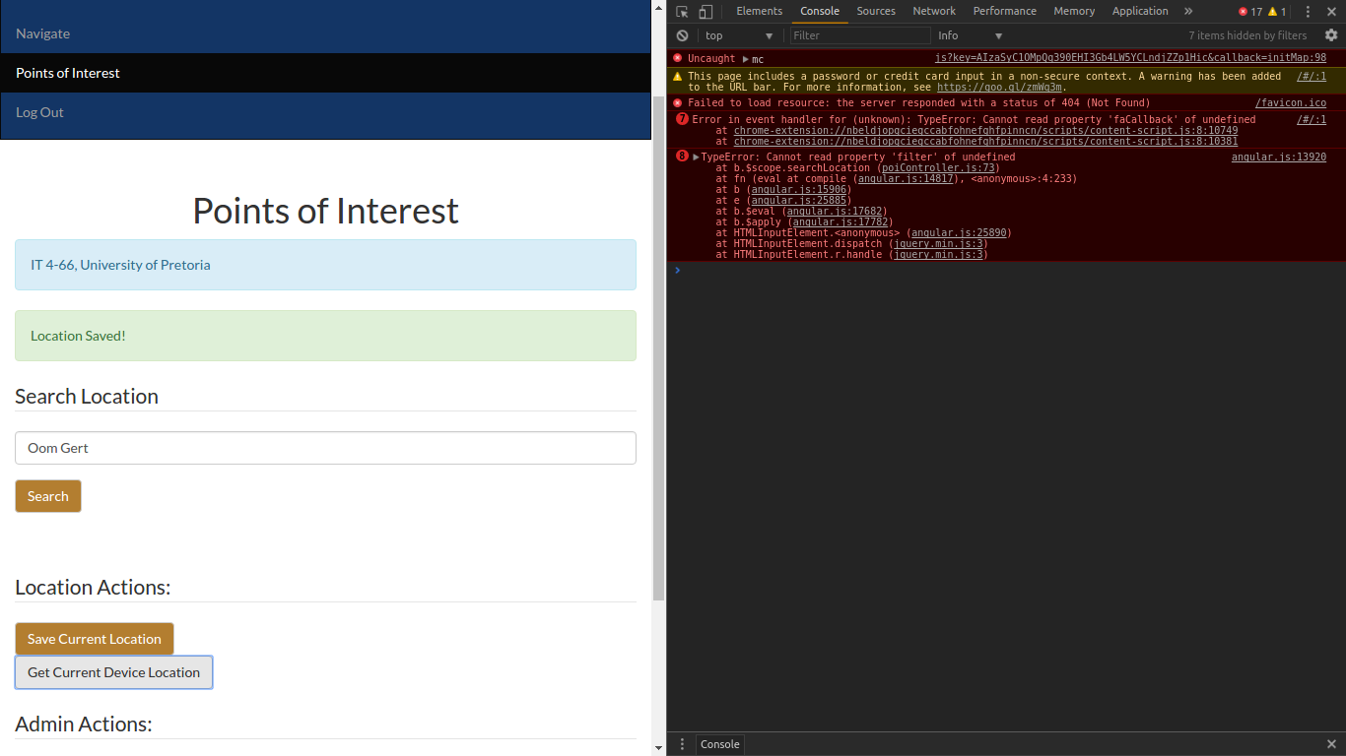Figure 3. Notification of saved location (green) and the current location (blue)

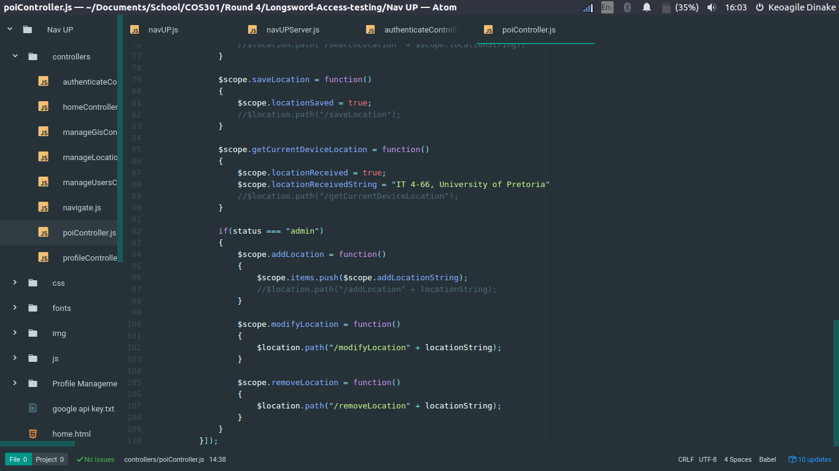Figure 4. Snippet of the admin related use cases, namely add location, modify location and remove location.

Case 1: Search Location

# Input values:

|  |  |  |  |  |  |
| --- | --- | --- | --- | --- | --- |
| Input Element | Type | Value Specification | Valid | Invalid | Exceptional Cases |
| Location | String | Non-empty string that is valid landmark name within campus. | Satisfies value specification | Does not satisfy value specification. | N/A |

## Test case generation:

### Test case generation/ Use case based tests:

|  |  |  |  |  |
| --- | --- | --- | --- | --- |
| Test case | Location | Valid | Expected result | Actual result |
| 1 | IT Building | Yes | Navigation from current location to the desired location, and the desired location details | Unknown |
| 2 | Hatfield Square | No | Error message | Unknown |
| 3 | Oom Gert | Yes | Navigation from current location to the desired location, and the desired location details | Unknown |

Case 2: Save Location

# Input values:

|  |  |  |  |  |  |
| --- | --- | --- | --- | --- | --- |
| Input Element | Type | Value Specification | Valid | Invalid | Exceptional Cases |
| Location | String | Non-empty string that is valid landmark name within campus. | Satisfies value specification | Does not satisfy value specification. | N/A |

## Test case generation:

### Test case generation/ Use case based tests:

|  |  |  |  |  |
| --- | --- | --- | --- | --- |
| Test case | Location | Valid | Expected result | Actual result |
| 1 | IT Building | Yes | Notification confirming success | Notification confirming success |
| 2 | Hatfield Square | No | Notification showing error | Notification confirming success |
| 3 | Oom Gert | Yes | Notification confirming success | Notification confirming success |

Case 3: Get Current Location

# Input values:

|  |  |  |  |  |  |
| --- | --- | --- | --- | --- | --- |
| Input Element | Type | Value Specification | Valid | Invalid | Exceptional Cases |
| N/A | N/A | Accurate GPS coordinates of the user’s current location | Satisfies value specification | Does not satisfy value specification. | N/A |

## Test case generation:

### Test case generation/ Use case based tests:

|  |  |  |  |  |
| --- | --- | --- | --- | --- |
| Test case | GPS Coordinates | Valid | Expected result | Actual result |
| 1 | N/A | Unknown | Notification indication the building name and room number | Notification indication the building name and room number |

Case 4: Add Location

# Input values:

|  |  |  |  |  |  |
| --- | --- | --- | --- | --- | --- |
| Input Element | Type | Value Specification | Valid | Invalid | Exceptional Cases |
| N/A | N/A | Name of a UP landmark, or building | Satisfies value specification | Does not satisfy value specification. | N/A |

## Test case generation:

### Test case generation/ Use case based tests:

|  |  |  |  |  |
| --- | --- | --- | --- | --- |
| Test case | Location | Valid | Expected result | Actual result |
| 1 | IT Building | Yes | New Point of Interest added | Unknown |
| 2 | Uncle Fauozi | No | Error Message | Unknown |

Case 5: Modify Location

# Input values:

|  |  |  |  |  |  |
| --- | --- | --- | --- | --- | --- |
| Input Element | Type | Value Specification | Valid | Invalid | Exceptional Cases |
| N/A | N/A | Details to relating to the Point of Interest | Satisfies value specification | Does not satisfy value specification. | N/A |

## Test case generation:

### Test case generation/ Use case based tests:

|  |  |  |  |  |
| --- | --- | --- | --- | --- |
| Test case | Location | Valid | Expected result | Actual result |
| 1 | IT Building | Yes | Point of Interest modification success notification | Unknown |
| 2 | Uncle Fauozi | No | Error Message | Unknown |

Case 6: Remove Location

# Input values:

|  |  |  |  |  |  |
| --- | --- | --- | --- | --- | --- |
| Input Element | Type | Value Specification | Valid | Invalid | Exceptional Cases |
| N/A | N/A | Name of a UP landmark, or building | Satisfies value specification | Does not satisfy value specification. | N/A |

## Test case generation:

### Test case generation/ Use case based tests:

|  |  |  |  |  |
| --- | --- | --- | --- | --- |
| Test case | Location | Valid | Expected result | Actual result |
| 1 | IT Building | Yes | Point of Interest removed successfully notification | Unknown |
| 2 | Uncle Fauozi | No | Error Message | Unknown |

Conclusion:

It is clear that the point of interest sub section was not completed and rather disappointing. Some non-functional requirements such as usability were not taken into consideration. This is seen with the stack of notifications that are not cleared from the screen, and do not have options to be cleared by the user. Most user input validation was set to default html input types, and not even use of the required attribute. All point of interest methods, that were bound to a functional requirement and several use cases, did not interact with the backend.

There was a lack of effort from this side of the Broadsword Access team.